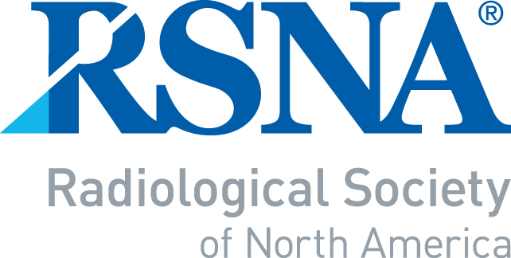 | 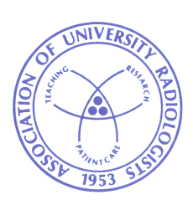 | 

2018 – 2019 RSNA/AUR/ARRS
INTRODUCTION TO ACADEMIC RADIOLOGY
NOMINATION/APPLICATION

Page 1 to be completed by Department Chair or Program Director

-- IMPORTANT NOTE --
- A response must be provided for each of the questions that appear below.
- Page 1 of the form must be signed (electronic signature is acceptable) by the Department Chair or the Program Director. A letter of recommendation is no longer required.
- Pages 1 and 2 are to be combined as one document and submitted as an electronic e-mail attachment to RSNA staff at: DOR@rsna.org to arrive no later than July 15, 2018.

Name of Department Chair or Program Director | Signature – REQUIRED (electronic signature is  acceptable)
Department Chair/Program Director’s e-mail

NOMINEE’S NAME
1. You may nominate one radiology resident, who will be a second- year (PGY-3) radiology resident at the time of the
RSNA/ARRS meetings.
2. What, in this candidate’s past performance, indicates that he/she has academic potential?
3. What are the candidate’s academic plans?
4. What is the mentoring program at your institution, and how do you plan to support this individual for
the remainder of his/her residency?
5. Are radiology residents in your program required to do research?
Yes |  | No
6. Is there a required research rotation?
Yes |  | No
If yes, what is the length of this rotation?
weeks
Nominee’s portion of the application follows on page 2.

Directions to the Nominee

The following section is to be completed by the nominee. (All items must be completed for consideration.)

Please note: Page 1 (Department Chair or Program Director’s section of the form) and Page 2 are to be fully completed, signed (electronic signature is acceptable) and submitted electronically as one attached document to staff at: DOR@rsna.org no later than July 15, 2018. Receipt of completed application will be acknowledged by email within 2-3 business days.

First Name: | Middle Initial: | Last Name: |  |  |  | Degree:
Age: |  | Gender:
Department: |  | Work phone:
Institution: |  | Home phone:
Institution address: |  | E-Mail:
Home address:
Have you taken (or will take) a radiology research elective? |  |  | Yes |  |  |  | No
If yes, how many months? |  |  | months
Total number of months of research training you anticipate having upon completion of your residency:
Are you currently involved in a research project?
If so, provide a brief description:

How many case reports have you authored or co-authored?

How many scientific abstracts have you authored or co-authored?

How many full length research publications have you authored or
co-authored?
*Please attach or insert a complete bibliography of all of your research publications of any type.
--Please do not submit your complete CV--

Please write a 50- to 100-word statement describing why you would like to be selected for the Introduction to Academic Radiology Program (when completed electronically, the box will expand).

Assignment to the RSNA or ARRS symposia will be made by the reviewers. However, if you are unable to attend either the RSNA or the ARRS program, please state the reason and we will do our best to accommodate your preference:
Deadline date for submission: July 15, 2018
Applicants will be notified with a decision by August 31, 2018
DOR@rsna.org
Radiological Society of North America
820 Jorie Boulevard
Oak Brook, IL 60523-2251

