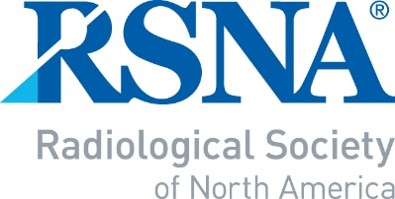

2022-2023 RSNA/AUR/ARRS
INTRODUCTION TO ACADEMIC RADIOLOGY
NOMINATION/APPLICATION

Page 1 to be completed by Department Chair or Program Director

-- IMPORTANT NOTE --
- A response must be provided for each of the questions below.
- Page 1 of the form must be signed (electronic signature is acceptable) by the Department Chair or the Program Director. A letter of recommendation is no longer required.
- The completed document must be submitted as an e-mail attachment to: RSNA staff at: DOR@rsna.org to arrive no later than July 15, 2022.

Name of Department Chair or Program Director | Signature – REQUIRED (electronic signature is  acceptable)
Department Chair/Program Director’s e-mail

NOMINEE’S NAME
You may nominate one radiology resident, who will be a second-year (PGY-3) radiology resident at the time of the
RSNA/ARRS meetings.
1. What, in this candidate’s past performance, indicates that he/she has academic potential?
2. What are the candidate’s academic plans?
3. What is the mentoring program at your institution, and how do you plan to support this individual for
the remainder of his/her residency?
4. Are radiology residents in your program required to do research?
Yes |  | No
5. Is there a required research rotation?
Yes |  | No
If yes, what is the length of this rotation?
weeks
Nominee’s portion of the application follows on page 2.

Page 2 to be completed by the nominee

All sections must be completed.

First Name: | Middle Initial: |  | Last Name: |  |  |  | Degree(s):
Age: | Gender: Choose an item. |  | Work phone:
Department: |  |  | Email:

Institution:

Affiliated university (if applicable):
Institution full address:
How did you hear about the ITAR program? Brochure Word of Mouth Email
Social Media RSNA.org
Have you taken (or will take) a radiology research elective? |  |  |  | Yes |  |  |  | No
If yes, how many months? |  |  |  | months
Total number of months of research training you anticipate having upon completion of your residency:
Are you currently involved in a research project?
If so, provide a brief description:
How many case reports have you authored or co-authored?

How many scientific abstracts have you authored or co-authored?

How many full-length research publications have you authored or
co-authored?
*Please attach or insert a complete bibliography of all of your research publications of any type.
--Please do not submit your full CV--

Please write a 50- to 100-word statement describing why you would like to be selected for the Introduction to Academic Radiology Program.

Assignment to the RSNA program or ARRS symposia will be made by the reviewers. However, if you are unable to attend either the RSNA or the ARRS program, please state the reason and we will do our best to accommodate your preference:

Submit the completed form as an e-mail attachment to DOR@rsna.org no later than July 15, 2022.

Receipt of your application will be acknowledged by email within 2 business days.

