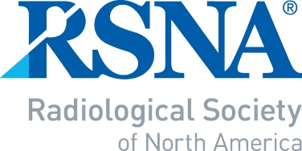
2022 RSNA
INTRODUCTION TO ACADEMIC RADIOLOGY FOR SCIENTISTS
NOMINATION/APPLICATION

Page 1 to be completed by Department Chair

-- IMPORTANT NOTE --
- A response must be provided for each of the questions below.
- Page 1 of the form must be signed (electronic signature is acceptable) by the Department Chair.
- The completed document must be submitted as an e-mail attachment to: RSNA staff at: DOR@rsna.org to arrive no later than July 1, 2022.

Name of Department Chair | Signature – REQUIRED (electronic signature is  acceptable)
Department Chair’s e-mail

NOMINEE’S NAME

You may nominate a postdoctoral fellow in the Imaging Sciences or Biomedical Engineering, no more than 6 years since doctoral conferment at the time of the RSNA Annual Meeting and Scientific Assembly.
1. What, in this candidate’s past performance, indicates that he/she has academic potential?
2. What are the candidate’s academic plans?
3. What is the mentoring program at your institution, and how do you plan to support the candidate’s academic career
development?
Nominee’s portion of the application follows on page 2.
Page 2 to be completed by the nominee

All sections must be completed.

First Name: | Middle Initial: | Last Name: |  | Degree(s):
Age: | Gender: Choose an item. | Work phone:
Department: |  | E-Mail:
Institution:
Affiliated university (if applicable):
Institution full address:
How did you hear about the ITARSc program? Word of Mouth Email
Social Media RSNA.org
Date of degree award:

Doctoral thesis title:

Please provide a brief description of your current research project(s)

How many scientific abstracts have you authored or co-authored?

How many full-length research publications have you authored or
co-authored?
*Please attach or insert a complete bibliography of all of your research publications of any type.
--Please do not submit your full CV--

Please write a 50- to 100-word statement describing why you would like to be selected for RSNA Introduction to Academic Radiology for Scientists Program.

Submit the completed form as an e-mail attachment to DOR@rsna.org no later than July 1, 2022.

Receipt of your application will be acknowledged by email within 2 business days.

