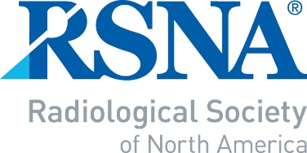
2022 RSNA
INTRODUCTION TO ACADEMIC RADIOLOGY FOR JUNIOR FACULTY
NOMINATION/APPLICATION

Page 1 to be completed by Department Chair or Vice-Chair for Research

-- IMPORTANT NOTE --
- A response must be provided for each of the questions below.
- Page 1 of the form must be signed (electronic signature is acceptable) by the Department Chair or Vice Chair of research.
- The completed document must be submitted as an e-mail attachment to: RSNA staff at: DOR@rsna.org to arrive no later than July 15, 2022.

Name of Department Chair or Vice-Chair of Reserach | Signature – REQUIRED (electronic signature is  acceptable)
Department Chair or Vice Chair of Research’s
e-mail

NOMINEE’S NAME

You may nominate one junior faculty member who has been out of training for no more than five years .

1. What, in this candidate’s past performance, indicates that he/she has academic potential?

2. What are the candidate’s academic plans?

3. What is the mentoring program at your institution, and how do you plan to support the candidate’s academic career
development?

Page 2 to be completed by the nominee

All sections must be completed.

First Name: | Middle Initial: | Last Name: |  | Degree:
Age: | Gender: Choose an item. | Work phone:
Department: |  | E-Mail:
Institution:
Affiliated university (if applicable):
Institution full address:
How did you hear about the ITARJF program Word of Mouth Email
Social Media RSNA.org
Completion date of training:

Are you currently involved in a research project? If so, provide a brief description:

How many case reports have you authored or co-authored?

How many scientific abstracts have you authored or co-authored?

How many full-length research publications have you authored or
co-authored?
Please attach or insert your curriculum vitae (CV).

Please write a 50- to 100-word statement describing why you would like to be selected for the RSNA Introduction to Academic Radiology for Junior Faculty program.

Submit the completed form as an e-mail attachment to DOR@rsna.org no later than July 15, 2022.

Receipt of your application will be acknowledged within 2 business days.

